Weather Monitoring System
Aryan Bawankar, Vishwajeet Dhamal, Devang Shinde, Avishkar Pagare
Department of Electrical Engineering, VJTI, Mumbai, Maharashtra, India
(arbawankar_b21@el.vjti.ac.in) (_b21@el.vjti.ac.in) (_b21@el.vjti.ac.in) (_b21@el.vjti.ac.in)

ABSTRACT

This project presents the development of a Weather Monitoring System aimed at collecting, processing, and visualizing environmental data. The system comprises a sensing node equipped with various sensors, an Arduino micro controller for data acquisition, and a Raspberry Pi 4 serving as a gateway. Communication between the sensing node and the gateway is achieved using a LoRa Radio Module operating at 435MHz. The Raspberry Pi 4 is responsible for transmitting data to a cloud platform.
At the cloud platform, data is stored in an Influx Database, where it is processed, parsed, and made available for visualization. Grafana is employed for data visualization, fetching data from InfluxDB to generate interactive graphs and indicators. This system provides a flexible and scalable solution for monitoring and analyzing weather-related parameters, with potential applications in agriculture, environmental monitoring, and research.
Keywords: Engineering, Technology, Raspberry Pi, Environment

- INTRODUCTION

Weather prediction and monitoring play crucial roles in various sectors such as agriculture, transportation, and disaster management. With the increasing concerns about climate change and its impacts, accurate and cost-effective weather monitoring systems are in demand. This project focuses on developing a Weather Monitoring System using IoT (Internet of Things) technologies to address these needs.
The system's design emphasizes cost-effectiveness and scalability, making it suitable for deployment in diverse environments. By leveraging the capabilities of Arduino and Raspberry Pi, the system can collect data from various sensors, including temperature, humidity, and rainfall sensors. The LoRa Radio Module enables long-range communication between the sensing node and the gateway, reducing the need for complex wiring and infrastructure.
The project's significance lies in its potential to contribute to climate change research and adaptation strategies. By providing real-time data on weather conditions, the system can aid in predicting and mitigating the effects of extreme weather events. Additionally, its cost-effective design makes it accessible to a wide range of users, including small-scale farmers and researchers.
Key components of the project include the Arduino micro controller, which serves as the brain of the sensing node, and the Raspberry Pi 4, which acts as the gateway between the sensing node and the cloud platform. The use of the Influx Database for data storage and Grafana for data visualization enhances the system's efficiency and usability.
Overall, this project demonstrates the potential of IoT technologies in developing practical solutions for weather monitoring and prediction. Its cost-effective design and scalability make it a promising tool for addressing the challenges posed by climate change.

- METHODS AND MATERIAL [ Page Layout ]

1. System Design:
- The system architecture consists of a sensing node and a Central Gateway.
- We designed the system around Star Topology.
- A number of Sensing Node can be connected to a Central Node. The Range of this network depends on LoRa Module range, that is in our case about 35km.
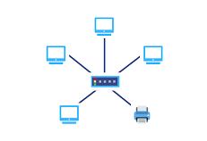

2. Communication Protocol:
- The MQTT Protocol is used for communication between the Raspberry Pi and the cloud platform.
- LoRa utilizes a spread spectrum modulation technique to achieve long-range communication and is characterized by its ability to penetrate obstacles and provide connectivity over long distances.
- LoRa can provide connectivity over several kilometres in rural areas and up to a few hundred meters in urban environments.
- Other communication protocols include SPI (Serial Peripheral Interface), I2C (Inter-Integrated Circuit) and UART (Universal Asynchronous Receiver-Transmitter) for communication between micro controller and devices.

3. Cloud Platform:
- The cloud platform Node-Red hosts an Influx Database for storing sensor data.
- InfluxDB is a time-series database designed to handle high write and query loads for time-stamped data. It is optimized for fast, high-availability storage and retrieval of time series data in fields such as monitoring, IoT, and real-time analytics. InfluxDB uses a SQL-like query language called InfluxQL for data retrieval and manipulation.
- Node-RED is a flow-based development tool for visual programming. It is built on Node.js and provides a browser-based editor that allows users to wire together devices, APIs, and online services. Node-RED is often used for IoT applications to create workflows that process data in real-time. It provides a wide range of nodes for integrating with hardware devices, cloud services, and databases, making it a versatile tool for building IoT applications.
- Data processing and parsing are performed in the cloud to prepare the data for visualisation.

4. Data Visualisation:
- Grafana is used for data visualisation, fetching data from the Influx Database.
- Grafana is an open-source analytics and monitoring platform. It allows you to query, visualise, alert on, and understand your metrics no matter where they are stored. It provides a powerful and elegant way to create, explore, and share dashboards and data with your team and the world. Grafana is commonly used for visualising time series data for infrastructure and application analytics.
- Grafana provides interactive graphs and indicators for monitoring weather conditions.

5. Sensor Calibration:
- Sensors are calibrated to ensure accuracy and consistency of data.
- Sensor used are:
  - DHT11
  - BMP280
  - MQ09
  - MQ135
  - GP2Y1010AU PM10 Sensor
  - Water Sensor
  - GPS Module
  - Light Intensity Sensor

6. Testing and Validation:
- The system is tested in real-world conditions to validate its performance.
- Testing includes verifying the accuracy of sensor readings and the reliability of communication between components.

7. Cost Analysis:
- The cost of components and materials used in the system is analysed to assess its cost-effectiveness.
- <<<<<< IN TOTAL AMOUNT >>>>>
- The analysis includes a comparison with existing weather monitoring systems to demonstrate the project's affordability.

8. Scalability and Future Work:
- The system's scalability is discussed, including the possibility of adding more sensors or expanding the network.
- Future work includes integrating additional sensors for measuring other weather parameters and enhancing data analysis capabilities.
- We aim to make low cost custom sensors for measuring wind Speed, Rain Gauge and Wind Direction.

- RESULTS AND DISCUSSION [Page Style ]

- Results:
The Weather Monitoring System was successfully implemented and tested in real-world conditions. The system was able to collect data from various sensors, including temperature, humidity, and particulate matter sensors, and transmit it to the cloud platform. The data was then stored in the Influx Database and visualized using Grafana.
The system demonstrated reliable communication between the sensing node and the gateway, with the ability to transmit data over long distances. Sensor calibration ensured accurate and consistent data collection, providing valuable insights into weather conditions.
- Advantages:
- Cost-effective solution for weather monitoring
- Scalable design allows for easy expansion with additional sensing nodes.
- Low power consumption, suitable for remote and off-grid locations
- Real-time data visualization enables quick decision-making
- Integration with cloud platform allows for data storage and analysis
- Disadvantages:
- Limited range of LoRa communication may require additional infrastructure in larger deployments
- Reliance on cloud platform for data storage and processing may introduce latency or data security concerns
- Calibration and maintenance of sensors may be required to ensure accuracy and reliability
- Initial setup and configuration may require technical expertise
- Susceptibility to environmental factors such as interference or weather conditions may affect data transmission

- Dashboard Results:
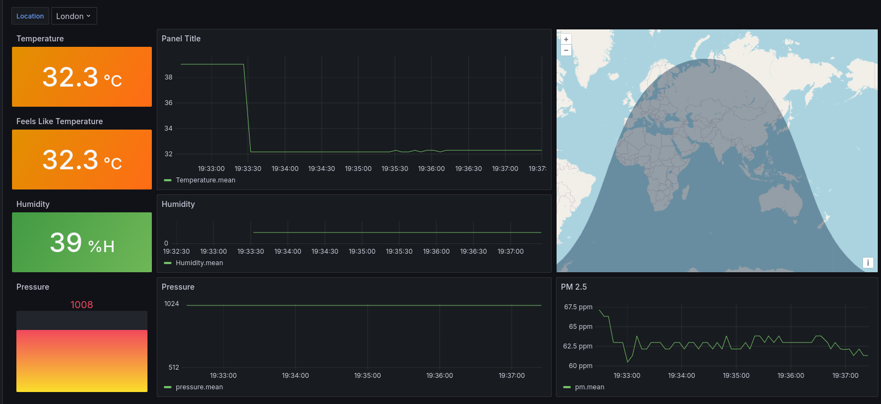

- CONCLUSION

In conclusion, the Weather Monitoring System developed in this project demonstrates the effective use of IoT technologies to collect, process, and visualize environmental data. The system's modular design, leveraging Arduino, Raspberry Pi, LoRa communication, InfluxDB, and Grafana, provides a scalable and cost-effective solution for weather monitoring. The project addresses the growing need for accurate and accessible weather data, particularly in the context of climate change and its impacts. By enabling real-time monitoring and analysis of weather conditions, the system can support various applications, including agriculture, environmental monitoring, and research.
Future enhancements to the system could include the integration of additional sensors for measuring other weather parameters, as well as the implementation of advanced data analysis techniques. Overall, this project serves as a foundation for further research and development in the field of IoT-based weather monitoring systems.

- Project Links
GitHub Link for Project: https://github.com/SubodhBawankar/Weather-Monitoring-System
Project Presentation:
https://www.canva.com/design/DAGFOHI09B4/E_XWRxDmCtKgfFEFZEpi8w/view?utm_content=DAGFOHI09B4&utm_campaign=designshare&utm_medium=link&utm_source=editor

- REFERENCES

- https://projects.raspberrypi.org/en/projects/build-your-own-weather-station
- https://iopscience.iop.org/article/10.1088/1742-6596/1470/1/012042

